1. **SYSTEM MODEL AND LITERATURE SURVEY:**

**BLOCK DIAGRAM:**

**DESCRIPTION OF VARIOUS BLOCKS:**

**Temperature and Humidity Sensor:**

A temperature and humidity sensor is a device that can measure both temperature and the amount of moisture in the air, which is referred to as humidity. These sensors are widely used in various applications including weather stations, HVAC systems, medical equipment, and home automation systems to monitor and control environmental conditions

**ARDUINO UNO:**

An Arduino Uno is a tiny computer that you can use to make cool stuff. It's like the brain for your projects. You can connect sensors, lights, and other things to it, and it will follow your instructions to control them. People use it to build things like robots, gadgets, and even games. You can write code (instructions) for it using a computer, and then the Arduino Uno does what you tell it to do. It's a great tool for learning about electronics and programming, and you can have lots of fun with it.

**16x2 LCD Display:**

A 16x2 LCD display is a popular type of display used in many electronics projects. It is called "16x2" because it can display 16 characters per line across 2 lines. This type of display utilizes a standard character set and provides a simple way of interfacing with a wide range of microcontrollers, such as Arduino, PIC, and Raspberry Pi, among others.

**COUPLER:**

These devices use light to transfer information between two isolated circuits, preventing high voltages from affecting the receiving side. They typically consist of a light-emitting diode (LED) and a photodetector like a phototransistor. Optocouplers are commonly used in power supplies, communication devices, and other applications where signal integrity and isolation are crucial.

**DC FAN:**

DC fans are essential for maintaining system stability and efficiency in many electronic systems by ensuring components operate within their thermal limits. They are chosen based on their performance characteristics matched to the cooling requirements of the application.

**2N2222 TRANSISTOR:**

The 2N2222 is a popular NPN bipolar junction transistor (BJT) used in various low-power amplification and switching applications. Its robustness and general availability have made it a go-to choice for hobbyists and professionals alike in the electronics community**.**

1. **HARDWARE DESCRIPTION:**

**CIRCUIT DIAGRAM:**

**LIST OF COMPONENTS:**

**ARDUINO UNO**

The Arduino Uno is a small computer thet helps you make all sorts of electronic gadgets. It has a brain called a micro controller that can follow your instructions. You can connect things like lights, sensors, and buttons to it using its pins. It gets power from from your computer through a USB cable or from a special plug. Ther are two tiny lights on it one that blinks and can be used for testing, and another you can control.

**Jumper wires**

Jumper wires are like the electric strings that connect things in a puzzle. They're small, flexible wires with pins on the ends. You can use them to link different parts of your projects, like connecting a sensor to a computer. Just like how you connect dots in a drawing with a line, you use jumper wires to connect electronic parts, making sure everything talks to each other. They come in different colors, which is like having different-colored strings in your puzzle, so you can keep things organized and figure out which wire goes where. They're handy tools for building and experimenting with electronics.

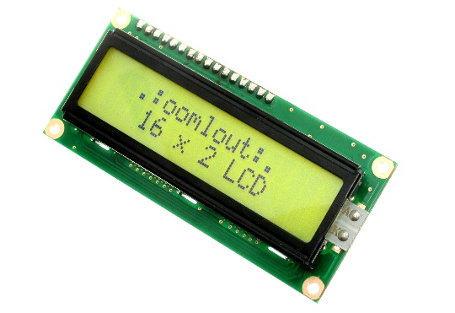

**16x2LCD**

The term [LCD stands for liquid crystal display](https://www.elprocus.com/difference-alphanumeric-display-and-customized-lcd/). It is one kind of electronic display module used in an extensive range of applications like various circuits & devices like mobile phones, calculators, computers, TV sets, etc. These displays are mainly preferred for multi-segment [light-emitting diodes](https://www.elprocus.com/light-emitting-diode-led-working-application/) and seven segments. The main benefits of using this module are inexpensive; simply programmable, animations, and there are no limitations for displaying custom characters, special and even animations, etc.

**Dht11 sensor**

The DHT11 is a basic, ultra low-cost digital temperature and humidity sensor. It uses a capacitive humidity sensor and a thermistor to measure the surrounding air and spits out a digital signal on the data pin (no analog input pins needed). It's fairly simple to use but requires careful timing to grab data.

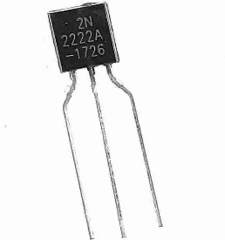

**2N2222 Transistor**

The 2N2222 is **a common NPN bipolar junction transistor (BJT) used for general purpose low-power amplifying or switching applications**. It is designed for low to medium current, low power, medium voltage, and can operate at moderately high speeds. It was originally made in the TO-18 metal.

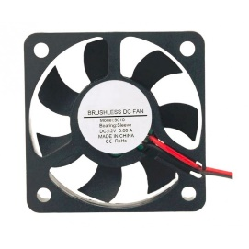

**DC Fan**

The **direct current fans**, or DC fans, are powered with a potential of fixed value such as the voltage of a battery. Typical voltage values for DC fans are, 5V, 12V, 24V and 48V.